

INFORMATICS INSTITUTE OF TECHNOLOGY

In Collaboration with

UNIVERSITY OF WESTMINSTER

**Recourse Recommendations System**

**according to Learning Style**

A Project Proposal by

Mr. Ushan Sankalpa

Supervised by

Mr. Cassim Farook

Submitted in partial fulfilment of the requirements for the BEng (Hons) Software Engineering degree at the University of Westminster.

**November 2022**

**Table of Contents**

1. Introduction 4

2. Problem Domain 4

3. Problem Definition 5

3.1. Problem Statement 5

4. Research Motivation 5

5. Existing work 6

6. Research Gap 9

7. Contribution to the Body of Knowledge 9

7.1. Technological contribution 9

7.2. Domain contribution 9

8. Research Challenge 9

9. Research question/s 10

10. Research Aim 10

11. Research Objectives 10

12. Project Scope 11

12.1. In-scope 11

12.2. Out-scope 12

12.3. Diagram showing prototype feature 12

13. Methodology 13

13.1. Research methodology 13

13.2. Development methodology 14

13.2.1. Life cycle model 14

13.2.2. Design Methodology 14

13.2.3. Evaluation Methodology 14

13.3. Project management methodology 14

13.3.1. Schedule 15

Gantt Chart 15

Deliverables 16

13.3.2. Resource Requirements 16

Software Requirements 16

Hardware Requirements 17

Data Requirements 17

Skill Requirements 17

13.3.3. Risk Management 17

References 18

# List of Figures

Figure 1 Prototype Diagram 13

Figure 2 Gantt Chart 16

# List of Tables

Table 1 Existing Work 9

Table 2 Research Objectives 12

Table 3 Research Methodology 14

Table 4 Deliverables 17

Table 5 Software Requirements 18

Table 6 Hardware Requirements 18

Table 7 Risk Management 19

**List of Abbreviations**

|  |  |
| --- | --- |
| Abbreviations | Definition |
| LO | Learning Outcomes |
| RO | Research Objectives |
| RQ | Research Questions |
| ML | Machine Learning |
| DL | Deep Learning |

# Introduction

E-learning systems are successfully employed for education and training in academic and non-academic contexts because of the Internet's explosive expansion. Several studies have addressed the need for personalization in the e-learning area, although many e-learning systems still lack it. Many of today's e-learning platforms continue to provide students with various learning preferences with the same educational materials in the same manner. Personalization in e-learning systems includes adaptive interaction, adaptive course delivery, content search and assembly, and adaptive collaborative assistance. This document defines the background of the problem, the existing works that are related to my research topic, the solution that Author planning to implement, and how Author supposed to address the currently facing issues.

# Problem Domain

Nowadays, most students learn using online resources. Even though students gained knowledge in universities, schools, and other institutes, they always tend to explore more to ability in their fields with the help of online sources. There are several types of online resources for different learning styles (visual, read and write, auditory). For example, some students may be interested in watching tutorial videos. It will help them to extract the content more than reading documentation. But some students are more interested in reading and gaining knowledge than watching a video. Sometimes we cannot find the most suitable learning type that suits us. When someone must be ready for an exam within two to three days, he/she must face difficulties in finding the best learning material for a specific subject that matches their learning style. In such cases, it would be a great solution to have an online resources recommendation system by identifying our learning styles.

The existing e-learning system's lack of personalization is another issue. There are students with comparable learning preferences. Even if they cater to distinct learning styles and similar learning resources, learning profiles for every student can address this issue. They consider that every student is catered to in the learning paradigm. Those systems will suggest educational material based on format. (Shao, n.d.)

Providing the appropriate student with the appropriate learning resources is another problem. The suggested solution can address this issue by employing content-based and collaborative filtering techniques. In content-based filtering, e-learners are shown related online information comparable to what they have already enjoyed, viewed, or found interesting. In collaborative filtering, online learners suggest related relevant web information that other online learners have already visited, appreciated, or liked. Information filtering is a strategy that makes use of resources for learners. These strategies operate based on a "ranked" or "preference" system.

# Problem Definition

Every student has a different learning style. Some students are visual learners, while some students prefer to learn through audio. The online learning system, with its range of options and resources, can be personalized in many ways. It is hard to find the perfect online material for our subject and learning style. It takes more time to try out various sources and find the relevant ones. The main issue with most online resources is reliability. Even though we found the perfect match for our choice, the information it contains may not be reliable.

This issue occurs when it cannot make pertinent recommendations due to a lack of knowledge about the prior preferences of e-learners. Another Collaborative filtering has the drawback of requiring a community of familiar learners. No collaborative filter can thus be suggested. Furthermore, results from content-based filtering cannot be shared since it takes each learner into account. The suggested system would include a range of surveys to determine the learners' initial learning styles and address information filtering issues.

## Problem Statement

Students are facing difficulties in finding the best online resources that match their learning styles.

# Research Motivation

As a university student, Author faced problems when choosing the right online sources when studying. It took me a period to find myself the best learning style that suits me. Author found it by trying and following videos, reading materials, and making notes. It takes some time. In some situations, Author had to watch so many tutorial videos from different sites to find the best one that meet my requirement. During the exam days, Author encountered complications finding the suitable reference.

# Existing work

|  |  |  |  |
| --- | --- | --- | --- |
| Citation | Brief Description | Limitations | Contribution |
| (Shao, n.d.) | Using the symbolic dataset from AI-Ismail, Gedeon, and Yamin's study, this paper offers a deep neural network (DNN) classification model to predict four preferences of mobile learners, including audio, PowerPoint, video, and e-books. | This study provides a way to create a learning material adaptation model that links a user profile to a content group using the Naive Bayes classifier and K-Means clustering method. | This research explores how to train a classification model with pre-encoded data to predict mobile learner preferences based on VARK scores. The popularity of mobile learning was a factor in the decision to use this dataset. |
| (“Intelligent Recommendations for e-Learning Personalization Based on Learner’s Learning Activities and Performances,” 2018)‌ | This recommendation system is an application that enables a user to propose an item based on their past choices and the preferences of a group of people who share their interests and worldviews. Therefore, recommendation systems both provide tailored access to material for a particular topic and aid learners in reducing the information overload they now experience. | This study suggests intelligent suggestions for an e-learning customization system that utilizes content-based filtering, collaborative filtering, and educational data mining techniques for recommendations and forecasts while also taking into consideration the learners' preferred learning styles. Here, we introduce a basic skill level test to identify the startup profile to solve the cold-start issue.  a new student. | The system encouraged learners to engage in various activities, such as completing numerous quizzes, throughout the e-learning process. Discuss, rank, evaluate, and bookmark subjects. to accumulate points the graphic displays the grades each student received. As a result, this point indication encouraged students to engage with the system more. |
| (Krishnamoorthy and Lokesh, 2020)‌ | Learning style preferences provide us insight on how to make better use of the educational materials at our disposal, especially with the growth of online and personalized learning platforms. On the idea that pupils like knowledge, Fleming and Bonwell created VARK learning styles. | The study investigated the connection between education and demographic elements including learning preferences and place of upbringing. The outcomes contradicted their theories, it turned out. They concluded that the development of big data learning style classification allows for the employment of a combination of stacking algorithms, such as voting classifiers or modeling algorithms, to adapt to user applications. | This study illustrates how machine learning algorithms may create correlations between several types of data. Students' learning styles have a significant role in how they assimilate knowledge while in school. |
| (De Medio et al., 2020)‌ | The web presents special potential in this article. Technologies and educational materials may make enormous sums of money. Simple options are available: For instructors, the internet is a vast resource where they may obtain helpful instructional materials for adding to or establishing courses. | The instructor can choose a specific LO from those on the rated list based on this analysis of prior uses of intriguing LOs. Based on their utilization, which was not included in the inquiry response, she/he may be encouraged to utilize additional LOs in addition to the pertinent LO in other courses. | In this paper, they focused on teaching activities. The presentation is an addition to the LMS that aids in helping the teacher create a course based on suggested LOs. The suggestions were made in response to features that LOs had requested as well as from the use of LOs by other teachers in various courses. |
| (Ezaldeen et al., 2019) | The major goal of online learning is to give people from all over the world access anywhere, at any time, and the ability to discover the right courses quickly and easily. | This study provides a way to create a learning material adaptation model that links a user profile to a content group using the Naive Bayes classifier and K-Means clustering method. | Incorporating intelligent support systems, this article proposes an AI-based e-learning system. Learning resources may be chosen depending on a student's ability and needs, assisting instructors and students in improving overall learning results. |

Table Existing Work

# Research Gap

The suggested solution is recommending learning resources for people with the same learning preferences using an algorithm to identify their learning styles. The accuracy can be improved using that algorithm. The users can also suggest learning materials they followed using the feedback form.

The existing recommendation systems only use normal algorithms and do not specify domains. When we are doing a system for an education category, we have enough ability to create a better output using specific knowledge. But that area has not been fully researched yet. Author planning to create a domain-specific improved personalized recommendation system by using the knowledge of the education domain and identifying the learning styles of students minimizing time waste.

# Contribution to the Body of Knowledge

## Technological contribution

There is a set of questions to be filled in by the user to identify his/her learning style. Machine learning is used there to extract the learning style from the answers the user provides. There is a feedback section, so previously logged students can share the resource that helped them. After the system identified the learning style of the user, it recommends learning materials and feedback from similar learning styles users using the machine learning algorithm.

## Domain contribution

The main drawback of e-learning and education systems is not being domain personalized. As a solution for that issue, a domain-specific recommendation system is designed using the learning style to save time and increase efficiency.

# Research Challenge

There are several challenges. The main challenge is that the author’s having to learn machine learning because there is no previous knowledge. The other challenge is the lack of research papers. There are dataset-related challenges too. In some identified datasets, the number of records in datasets is not enough.

# Research question/s

RQ1: How to design and develop a maintainable resource recommendation system according to the learning style of the students?

RQ2: What aspects of e-learning and outside influences influence the usefulness of a recommendation system?

# Research Aim

The aim of the research is to design, develop and evaluate a web-based solution that recommends accurate learning resources according to the learning preference of the similar learners.

# Research Objectives

The below research objectives must be successfully completed to achieve the above aim and research questions.

|  |  |  |
| --- | --- | --- |
| Research Objectives | Explanation | Learning Outcome |
| Literature Review | Compare previous research work critically before reading and collecting them  RO1: Conduct research on the existing resource recommendation system and its architecture  RO2: Conduct research on the learning styles of students and e-learning  Ro3: Examine resource recommendation techniques  RO4: Analyse factors about the desires and preferences of students | LO1, LO4, LO8 |
| Data Gathering and Analysis | Identify the requirements of the project by understanding the gaps in previous research works and by using techniques and tools  RO1: Collect information about the desire of students for e-learning and online education  RO2: Gather requirements of recommendation systems and understand the software requirements.  Ro3: Meet domain experts and ask for their ideas | LO1, LO3, LO5 |
| Research Design | Design a system that can solve identified problems and designed architectures  RO1: Identify the learning style of the students  RO2: Design a resource recommendation system with machine learning according to the learning style  RO3: Design the system to improve the DL or ML resource recommendation model | LO1, LO5, LO8 |
| Implementation | Implement a system to solve the identified gaps and achieve the aim  RO1: Develop a recommendation system that provides accurate resources  RO2: Develop an algorithm to recommend resources according to the learning style. | LO1. LO5, LO7 |
| Testing and Evaluation | Test the implemented data science model and designed system  RO1: Create a test plan for functional testing | LO1. LO5 |

Table Research Objectives

# Project Scope

Based on the project objectives and an evaluation of comparable goods while considering the time limit allotted for this research project, the scope is described as follows.

## In-scope

* Provide a questionnaire to identify user learning style using machine learning algorithm.
* Ability to get user feed (rating) for resources using feedback form.
* Recommending learning resources according to similar learners’ feedback using a Machine Learning algorithm.
* Ability to search resources.
* User profile maintenance.
* Administrators can insert learning resources.

## Out-scope

* Currently providing only selected resources (Learning resource limitation)
* In the beginning, the recommendation is reduced due to a feedback shortage.
* Learning style identifying test will not contain essay type of questions.
* Inability to identify inside of the resources.

## Diagram showing prototype feature

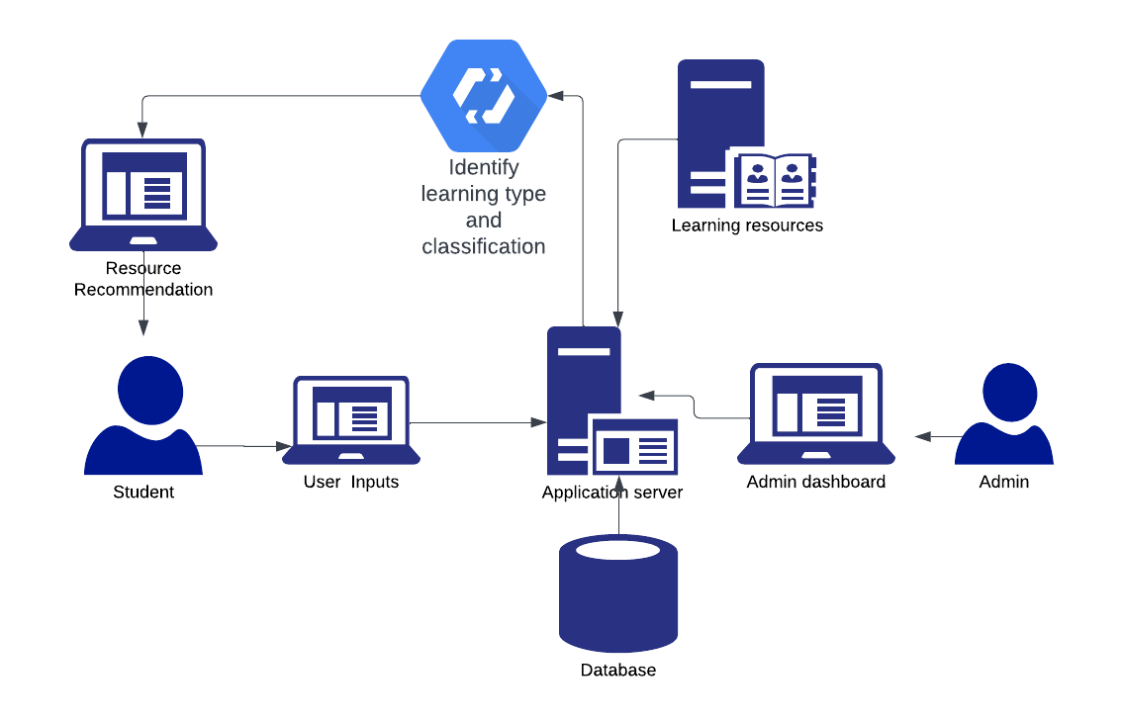

Figure Prototype Diagram

# Methodology

## Research methodology

|  |  |
| --- | --- |
| Research Philosophy | According to positivist research, knowledge exists independently of the subject being investigated. In other words, the subject of the study must be impartial; it cannot reflect the ideas or viewpoints of the researcher, who only records data. According to positivism, there is just one reality, and all meanings are constant across subjects.  Positivists believe that empirical inquiry built on measurement and observation is the only way to get knowledge. In other words, all information is posteriori knowledge, the knowledge that is obtained from study rather than human thinking. |
| Research Approach | When examining alterations in the physical characteristics of animals through time, a logical strategy is used, which has its roots in the theory of evolution. In other words, a reputable, already-existing research organization serves as the beginning point. |
| Research Strategy | Archival research is the last but not the least. A study of the data provides context for an archival research technique, which draws on already-existing resources. This approach may make use of resources like manuscripts and documents and is especially well suited to historical study. |
| Research Choice | There are several techniques. people will employ a variety of methodologies, including more than one quantitative and one qualitative approach, when people apply a multi-method approach. For example, consider doing research using archives from a certain culture. To examine numerical data, they can utilize two qualitative approaches in addition to quantitative methods. |
| Time zone | Like all other decisions, choosing a time horizon is based on the nature of the research's goals and objectives. Additionally, we must consider practical limitations like the time they have to finish studying. |

Table Research Methodology

## Development methodology

### Life cycle model

Software Development Agile Since iterative development is necessary, life cycle was selected as the research development approach. Iterative and incremental process paradigms create the agile software development life cycle. Through process flexibility and quick delivery of effective software solutions, it places a strong emphasis on client satisfaction. Production is divided into brief incremental builds by agile. Iterative builds are offered for these.

### Design Methodology

The incremental model is a software development cycle in which requirements are broken down into several modules. Each module in this paradigm goes through the requirements, design, implementation, and testing processes. The capability of the module is increased with each new edition. Up till the entire system is established, the procedure is continued.

### Evaluation Methodology

Creating an evaluation process entails devoting specific resources, identifying the expected results, and including them in the project planning. Next, determine the techniques and the time range for obtaining the results.

## Project management methodology

Agile project management has inspired several other sub-frameworks and approaches. Agile project management approaches strongly emphasize teamwork, speed, and adaptability to data-driven change. Because of this, agile project management approaches often feature brief work periods with regular testing, appraisal, and modification.

### Schedule

### Gantt Chart

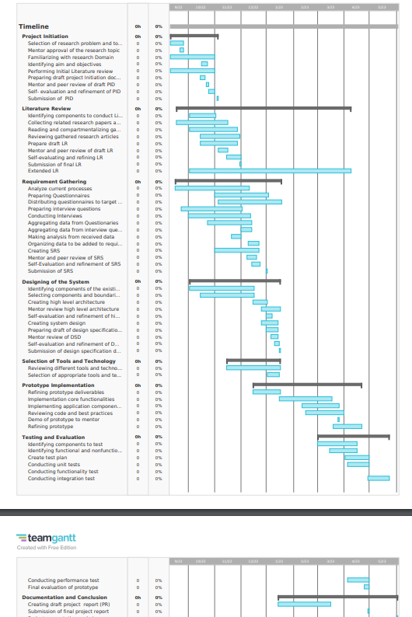

Figure Gantt Chart

### Deliverables

|  |  |
| --- | --- |
| **Deliverable** | **Date** |
| Project Proposal Document | 3rd November 2022 |
| Literature Review Document | 15th November 2022 |
| Software Requirement Specification | 24th November 2022 |
| System Design Document | 23rd January 2023 |
| Prototype | 2nd February 2023 |
| Thesis | 30th March 2023 |
| Review Paper | 3rd February 2023 |
| Manuscript Paper | 17th February 2023 |
| Final Research Paper | 27th April 2023 |
| Public project library | 3rd July 2023 |

Table Deliverables

### Resource Requirements

### Software Requirements

|  |  |
| --- | --- |
| Software Requirements | Solutions |
| Operation System | Windows, Linux |
| Programming Language | Java, Python, JavaScript |
| Frameworks | Flask, Angular, Node js, |
| Diagram Design Tools | Drow.io |
| Project Management Tools | Mendeley, Zotero |
| Documentation Tool | Microsoft word, Google sheet, Microsoft excel |
| IDE | Jupiter notebook, IDEA, Anaconda, PyCharm |
| Libraries | TensorFlow/ Scikit learn Python packages |

Table Software Requirements

### Hardware Requirements

|  |  |
| --- | --- |
| * 16 GB Memory or above. * 15 GB Storage or above * Core i7 processor | To be able to develop the Resource Recommendation System and to store the data and code. As well as managing the dataset and training process. |

Table Hardware Requirements

### Data Requirements

* **Student learning preference** - Kaggle open datasets. Use as ML dataset

### Skill Requirements

* Creation of required Resource Recommendation Systems.
* Ability to train and optimize Machine learning and Deep learning Models.
* Creative writing and Research writing skills.
* Knowledge of ML and DL.

### Risk Management

|  |  |  |  |
| --- | --- | --- | --- |
| **Risk Item** | **Severity** | **Frequency** | **Mitigation Plan** |
| Existing development code is no longer accessible. | 5 | 3 | Keep an external backup and GitHub backups of development code. |
| Getting lost in the paperwork | 4 | 4 | Use daily backups and a cloud-first approach to documentation (One-drive & Google drive). |
| Failure to accomplish all anticipated deliveries within the time frames set out. | 4 | 2 | Work on deliverables according to a timeline and priority basis. |
| Due to sickness, Unable to describe research work. | 2 | 1 | Record demonstration and detailed documentation with an explanation. |

Table Risk Management

# References

de Medio, C., Limongelli, C., Sciarrone, F., Temperini, M., 2020. MoodleREC: A recommendation system for creating courses using the moodle e-learning platform. Comput Human Behav 104, 106168. <https://doi.org/10.1016/J.CHB.2019.106168>

Ezaldeen, H., Misra, R., Alatrash, R., Priyadarshini, R., 2019. Machine Learning Based Improved Recommendation Model for E-learning. International Conference on Intelligent Computing and Remote Sensing, ICICRS 2019 - Proceedings. <https://doi.org/10.1109/ICICRS46726.2019.9555866>

Intelligent Recommendations for e-Learning Personalization Based on Learner’s Learning Activities and Performances, 2018. . International Journal of Computer Science and Software Engineering (IJCSE). <https://doi.org/10.13140/RG.2.2.12672.74241>

Krishnamoorthy, D., Lokesh, D., 2020. Process of building a dataset and classification of vark learning styles with machine learning and predictive analytics models. Journal of Contemporary Issues in Business and Government 26. <https://doi.org/10.47750/cibg.2020.26.02.128>

Shao, Y., n.d. Prediction of preferences on M-Learning based on VARK score using DNN to classify multi-label and single-label data.

Lu, J. *et al.* (2015) “Recommender System Application Developments: A survey,” *Decision Support Systems*, 74, pp. 12–32. Available at: https://doi.org/10.1016/j.dss.2015.03.008.

Dutsinma, F.L. *et al.* (2018) “Identifying child learning style by using human physiological response and Vark Model,” *2018 Global Wireless Summit (GWS)* [Preprint]. Available at: https://doi.org/10.1109/gws.2018.8686547.

Luangrungruang, T. and Kokaew, U. (2022) “Adapting fleming-type learning style classifications to deaf student behavior,” Sustainability, 14(8), p. 4799. Available at: https://doi.org/10.3390/su14084799.